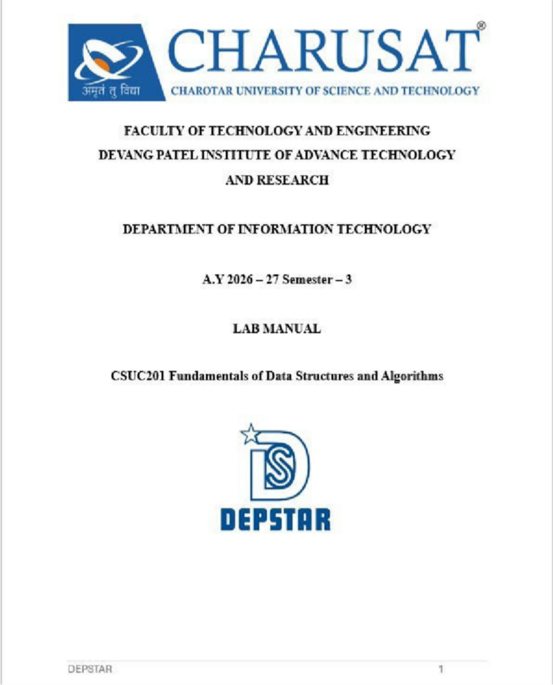

Practical 1: Array Operations: Traversal, Rotation, and Frequency Analysis Problem 1
A bakery prepares n items every morning and places them in a display row. At the end of each
hour, the leftmost item is moved to the rightmost position to make room for fresh stock at the front. Given the initial row and the number of hours h, print the final display order.
Describe the approach you used. How does it behave when h is very large, say 10 million? Is there a way to get the correct result without performing the operation h times?

Code:-
https://github.com/RudraKapuriya/DSA-Practical/blob/main/Practical%201/Practical_1_1.cpp

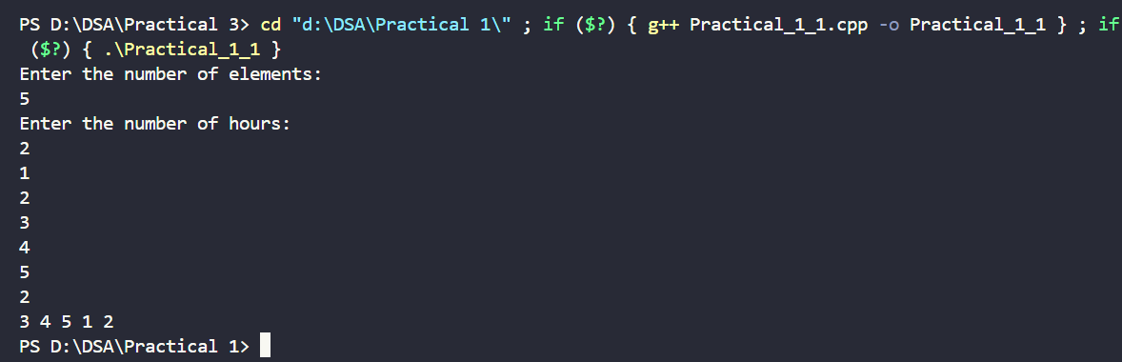
Output:-
Problem-faced:-
Difficulty I show Regarding Problem Solving
In this problem I one the I want to learn optimal approach to solve this problem here I used two for loop I want learn how to solve without using second loop within solve only 1 loop that is learn in this problem .

Problem 2
A library issues books to students and records each book's ID every time it is borrowed. At th end of the month, the librarian wants to find all books that were borrowed more than once, as those need priority restocking. Given the borrowing log, print all such book IDs.
Describe the approach you used. How many times does your solution scan the data? If the library had 100,000 borrow records, would your approach still be practical? Can you think of a way that requires fewer passes?

Code:-
https://github.com/RudraKapuriya/DSA-Practical/blob/main/Practical%201/Practical_1_2.cpp

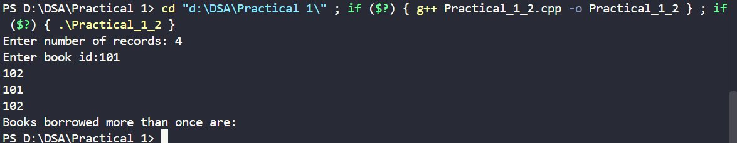
Output

Problem-faced:-
Here is I show some difficulty how to check each and every element 1 time we have check 0 to i then I check i+1 to n after this problem I have been solved.

Problem 3
A school newspaper editor wants to highlight the most impressive word from a submitted article
on the front page. The word is chosen simply by length — the longest one wins. Given a sentence, print the winning word and how many letters it has.
Describe the approach you used. What does your solution do when two words have the same length? Is that behavior intentional, and can you think of a way to handle it explicitly?

Code:-
https://github.com/RudraKapuriya/DSA-Practical/blob/main/Practical%201/Practical_1_3.cpp

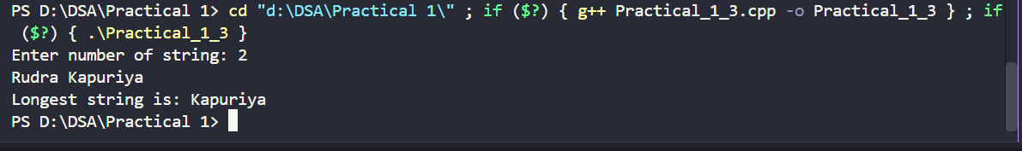
Output:-

Problem-faced:-
Here this problem I have been solved by using string library then I peak empty string they store temporary then empty string will be stored null character them find max length string and number string length.

Conclusion:-
This lab demonstrated three core DSA concepts: optimizing repeated operations using cyclic patterns (Problem 1), efficient frequency counting with hash maps for single-pass duplicate detection (Problem 2), and linear search with proper input preprocessing (Problem 3).
Together, they show that recognizing patterns and choosing the right data structure often matters more than brute-force computation for writing efficient, scalable solutions.

Practical 2
To implement linear and binary search using both iterative and recursive approaches.
Problem-1
A security guard at a parking lot checks vehicles one by one from the entrance to find a car with a specific license plate. Sometimes he starts from the entrance, sometimes he calls a helper who starts from where the guard left off. Given a list of license plates and a target plate,
implement both approaches — one that checks plates one by one from the start, and one where
the function calls itself to continue checking — and report the position of the target plate if found.
Describe the approach you used. What happens in your solution if the target plate appears more than once in the list? Does it find the first occurrence, the last, or just any one?

Code:-
https://github.com/RudraKapuriya/DSA-Practical/blob/main/Practical%202/Practical_2_1.cpp

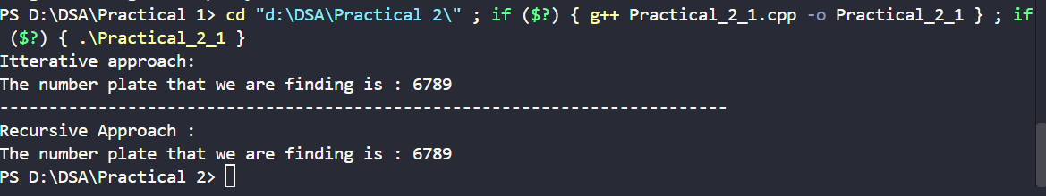
Output:-

Problem-faced:
Here I show first how break when leave the middle of checking after helper arrive hoe fetch already continues loop that is biggest error I have occurred but it error I have been solved with using recusive function they return same function but next index value they will be taken.

Problem-2:
A librarian maintains a sorted catalog of book codes and needs to locate a specific code quickly. Instead of going through every book, she opens the catalog to the middle, checks whether the target is to the left or right, and repeats. Given a sorted list of book codes and a target code,
implement both approaches — one using a loop and one where the function calls itself — and
report the position of the target code. Describe the approach you used. What is the one condition your input must satisfy for this approach to work correctly? What would go wrong if that condition was not met?

Code:-
https://github.com/RudraKapuriya/DSA-Practical/blob/main/Practical%202/Practical_2_2.cpp

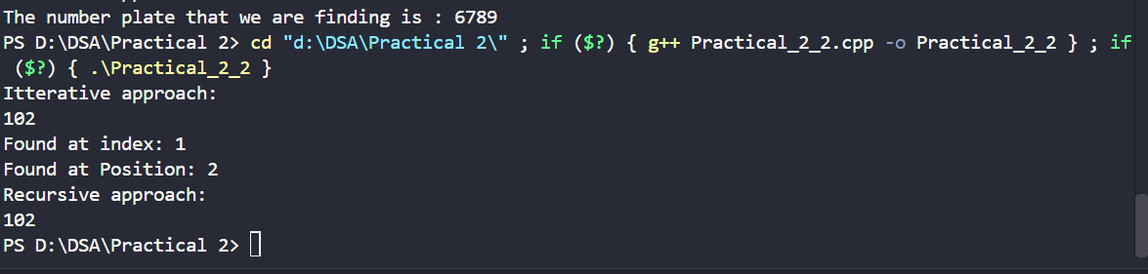
Output:-
Problem-faced:
While implementing this problem, I faced challenges in correctly updating the left and right boundaries after comparing the middle element with the target. I also had to write the proper base case in the recursive approach to stop the search when the target was not found. This
approach works correctly only if the list is sorted. If the list is not sorted, the search may discard the part containing the target and produce an incorrect result or fail to find the target even when it exists.

Conclusion:-
This lab compared linear and binary search approaches, showing that sorted data enables far more efficient searching (O(log n) vs O(n)) but only when the sortedness condition truly holds. It also demonstrated how exploiting structural properties — like row/column order in a grid — reduces search cost from O(n²) to O(n), reinforcing that data structure and precondition checks are as important as the algorithm itself.

Practical - 3

Practical Aim
To implement and compare multiple sorting algorithms and develop the ability to reason about
which sorting strategy suits a given situation.

PR-3.1
A teacher has a stack of student answer sheets with marks written on them and needs to
arrange them in order before entering grades. She tries three different methods: in the first, she
repeatedly compares adjacent sheets and swaps them if they are out of order; in the second, she finds the lowest-marked sheet each time and places it at the front; in the third, she picks each sheet one by one and inserts it into its correct position among the already-arranged sheets. Implement all three methods and for each one, print the sorted order of marks.
Describe how each of the three methods works in your own words. If the sheets were already in
order before the teacher started, which method would finish the fastest and why?
Code:-
https://github.com/RudraKapuriya/DSA-Practical/blob/main/Practical%203/practical_3_1.cpp

Output:-

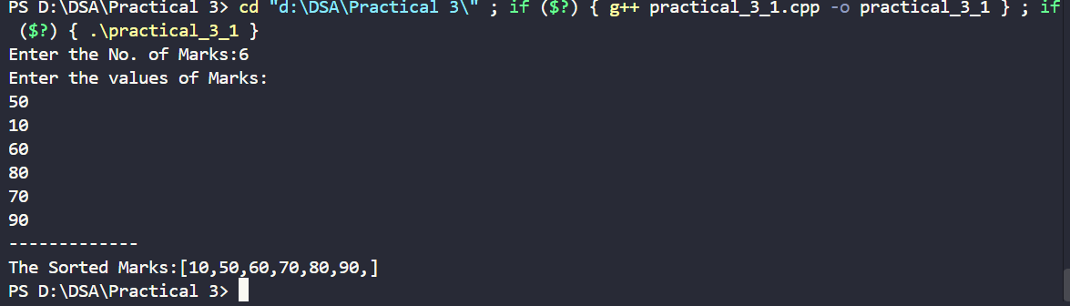

Problem-faced:-
In this practical I have been learned diff types of shorting algorithm like bubble short ,
insertion , selection short 1. In the bubble short compare two adjustment element and swap
them according condition , 2. In insertion short first take index 0 element as a shorted array and another element compare their previous element until if it previous element smaller than
current element 3. Selection short first find min element and add the front index of array.

PR-3.2
A paint shop has buckets labeled with one of three colour codes — 0, 1, or 2 — but they are
stored in a random order. The shop owner wants all 0s together, then all 1s, then all 2s, without using any extra storage. Given the list of colour codes, rearrange them in place and print the
result.
Describe the approach you used. Does your solution make more than one pass through the list? Can you think of a way to do it in exactly one pass?

Code:-
https://github.com/RudraKapuriya/DSA-Practical/blob/main/Practical%203/practical_3_2.cpp

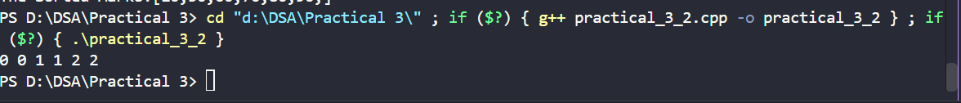
Output:-
Problem-faced:-
In this practical I have been performed dutch national flag algorithm problem in this problem first find total number of one,two and zero than add array via loop but first add 0 like while(zero--) loop runs until condition false inside loop arr[index]=0 , declare index =0 then when first loop end start next loop same as first …. And of inside array first show like
0,0,0,1,1,2,2

Conclusion:-
This lab implemented and compared bubble, selection, and insertion sort, showing each method's mechanics and that insertion sort performs best (O(n)) on already-sorted input due to its early-exit comparison, unlike bubble and selection sort's fixed passes. The Dutch National
Flag problem (Problem 2) further demonstrated how in-place partitioning with three pointers can sort a three-valued array in a single pass without extra storage, reinforcing that algorithm choice should depend on input characteristics and constraints like memory and pass count.

Practical - 4

Problem 4.1
A hospital manages a queue of patient tokens. New critical patients must be added to the front, routine patients are added to the end, and occasionally a patient with a priority number must be inserted at a specific position in the queue. Given a sequence of such operations, implement all three insertion types and print the final queue after each operation. Describe how your insertion at a specific position works. What does your solution do if the position given is greater than the current length of the queue? Is that handled explicitly or does it cause an error?

Code:

https://github.com/RudraKapuriya/DSA-Practical/blob/main/Practical%204/practical_4_1.cpp

Output:

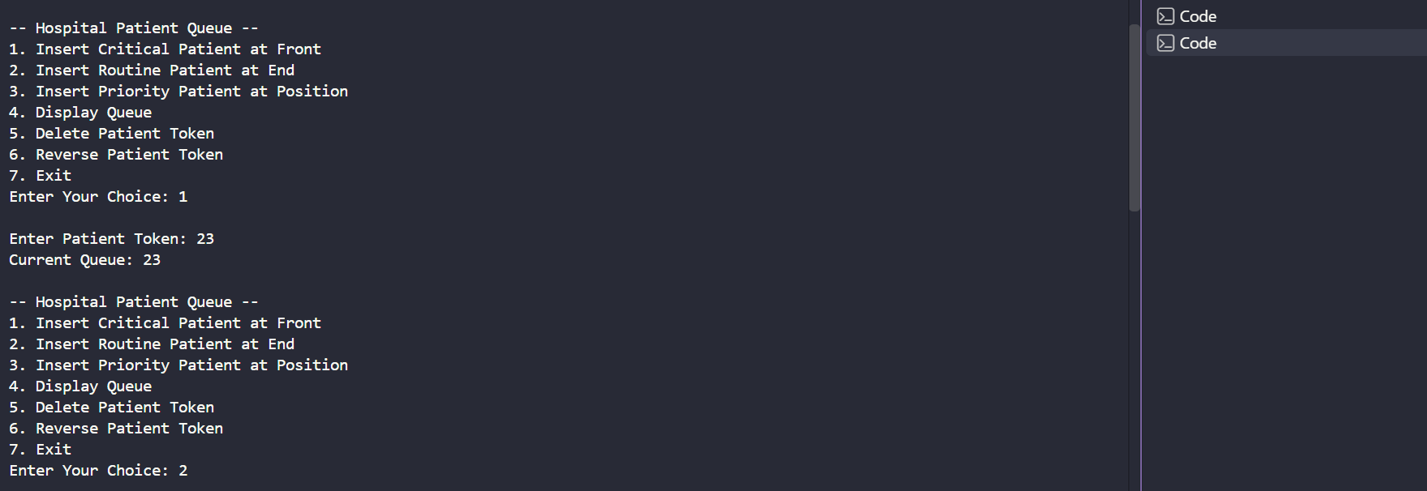

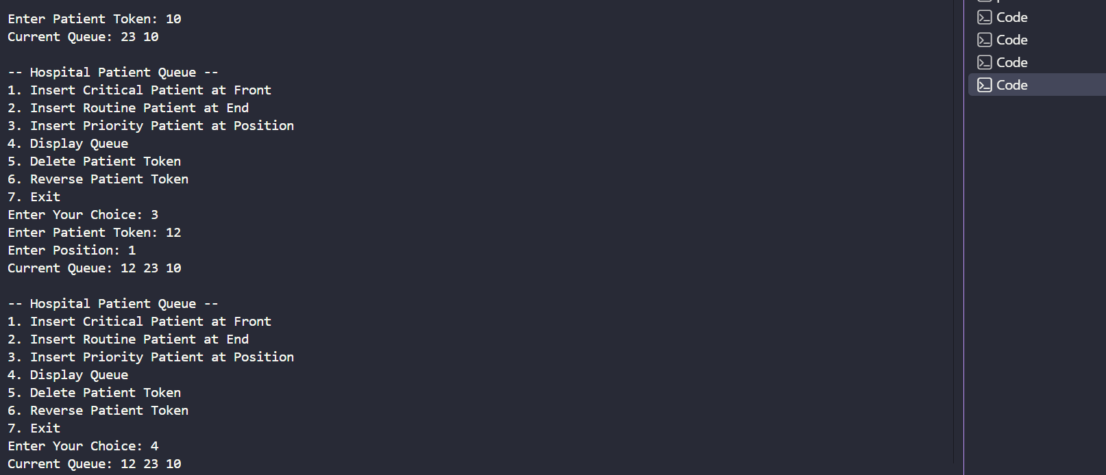

Problem Faced:
I faced problem in reverse-queue in this practical and also got issues with putting priority patient position.

Problem 4.2:
The hospital also needs to remove a patient token from the queue when a patient leaves, print all remaining tokens from last to first for an end-of-day audit, and display the full queue from front to back at any point. Implement deletion by value, reverse printing, and forward traversal on the same queue from Problem 4.1a. Describe how your reverse printing works. Does it use any extra storage, or does it work purely by following the links? Can you think of another way to reverse-print without modifying the original queue?

Code:

https://github.com/RudraKapuriya/DSA-Practical/blob/main/Practical%204/practical_4_2.cpp

Output:

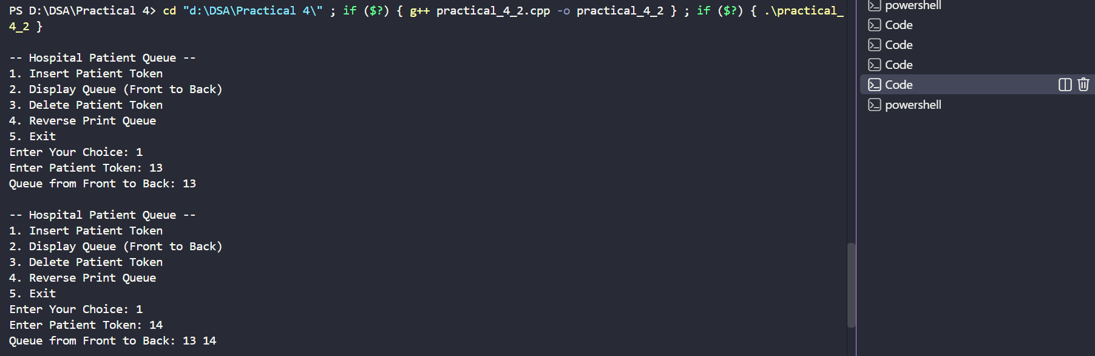

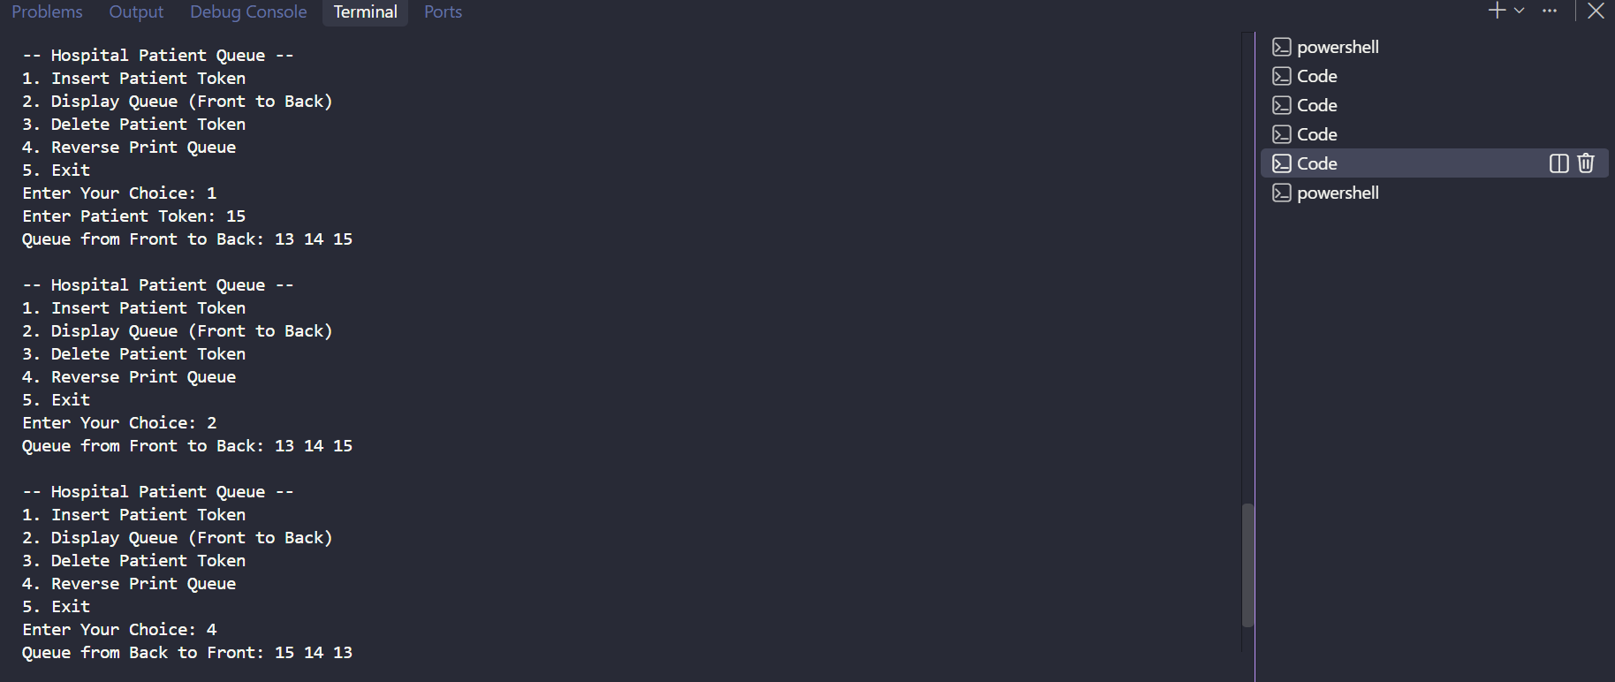

Problem- faced:
Finding a patient token that does not exist in the queue required proper traversal and condition checking.
Understanding recursion in the reverse function was challenging because the nodes are printed only after reaching the last node.

Practical 5

Problem 5.1:
A music player maintains a playlist where songs can be added to the beginning, added to the end, or inserted right after a specific song that is currently playing. When a song is removed, only the first song in the playlist is dropped. At any point the player can count how many songs are in the playlist and display them from first to last. Given a sequence of such operations, implement all of them on a doubly linked playlist and print the result after each operation. Describe how your insertion after a given song works. What extra step does a doubly linked list require here that a singly linked list did not? What happens if the given song is not found in the playlist?

Code:

https://github.com/RudraKapuriya/DSA-Practical/blob/main/Practical%205/Practical5_1.cpp

Output:

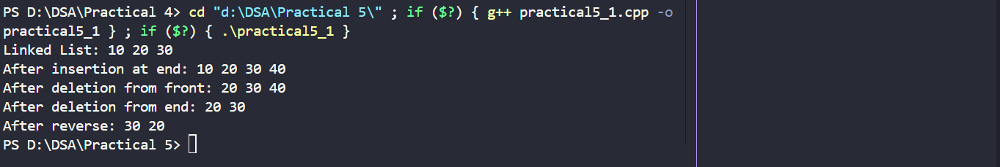

Problem-faced:
Handling deletion of the node from the middle was difficult.

Problem 5.2:
A group of students are sitting in a circle playing a passing game. A token starts at the first student and is passed around the circle one student at a time. Students can join the circle at any position and leave at any time, and the circle must remain unbroken after every join or leave. Given a sequence of join, leave, and display operations, implement them on both a singly circular and a doubly circular linked list and print the current circle after each operation. Describe how your solution ensures the circle stays unbroken after a student leaves. What is the one case where breaking the circle is most likely to happen as a bug, and how did you handle it?

Code:

https://github.com/RudraKapuriya/DSA-Practical/blob/main/Practical%205/Practical5_1.cpp

Output:

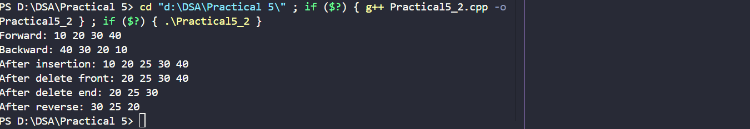

Problem-faced:
Reversing the doubly linked list was difficult because both directions of every node had to be swapped without losing the connection between nodes.
Implementing insertion and deletion at a specific position required careful traversal and correct adjustment of neighboring nodes.

Practical 6:

Problem 6.1:
A cafeteria stacks clean trays on a fixed-size counter. New trays are always placed on top, and customers always take from the top. The counter can hold at most n trays at a time — if it is full, no more trays can be added, and if it is empty, no tray can be taken. Given a sequence of place and take operations, implement this fixed-capacity tray stack and print the current top tray after each operation. Report an error if a place or take operation cannot be performed. Describe how your solution tracks whether the stack is full or empty. What are the exact conditions you check before a push and before a pop, and what does your program do when those conditions fail?

Code:

https://github.com/RudraKapuriya/DSA-Practical/blob/main/Practical-6/Practical6_1.cpp

Output:

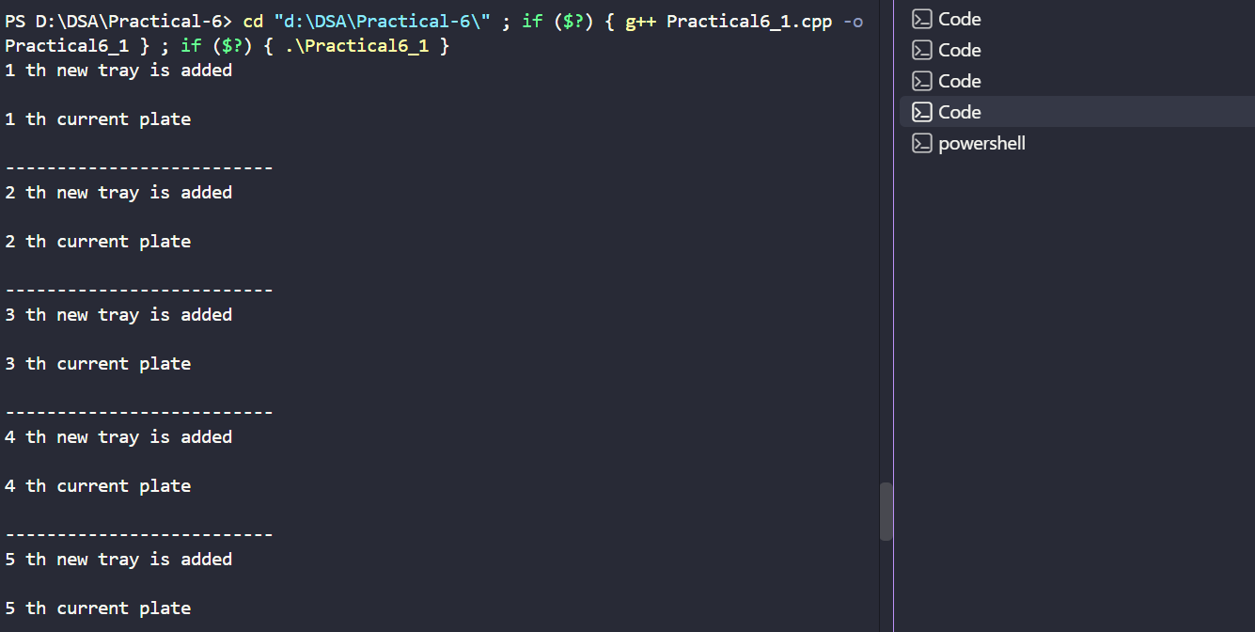

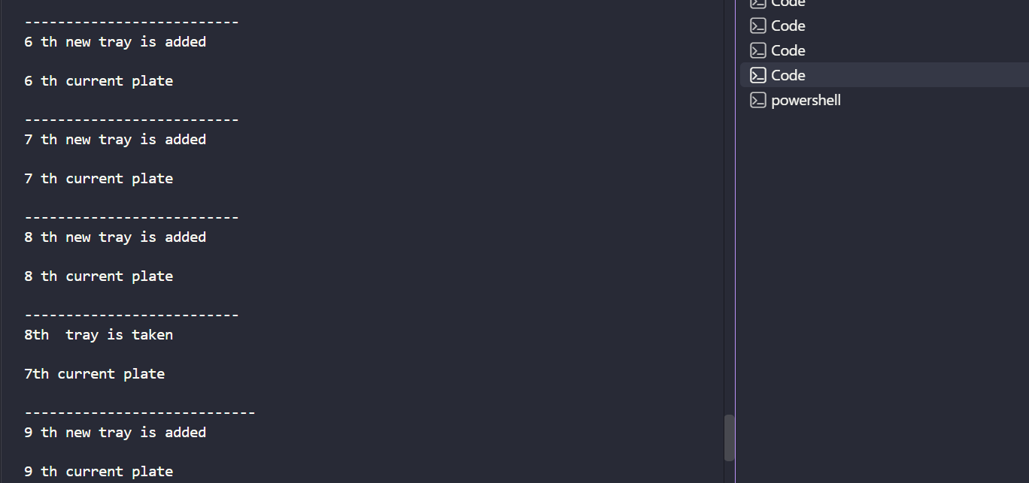

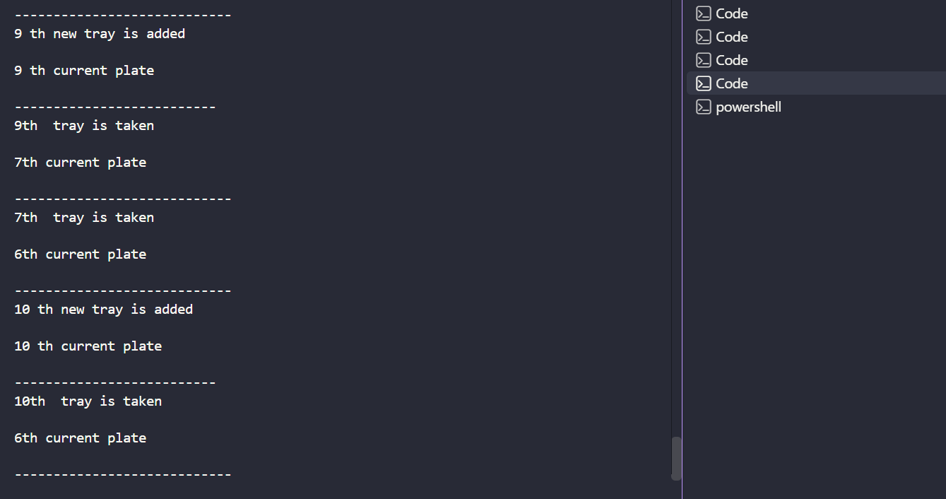

Problem-faced:
Keeping track of the current top tray after every insertion and deletion required careful manipulation of the array index.
Handling the condition when the last remaining tray is removed required additional checking to avoid accessing an invalid array position.
Managing a fixed-size stack meant considering the maximum capacity and preventing insertion when all 15 positions were occupied.

Problem 6.2:
A web browser keeps track of pages visited so that the back button always returns to the most recently visited page. Unlike a fixed counter, the browser has no hard limit on how many pages it can remember — it grows as the user visits more pages and shrinks as they press back. Given a sequence of visit and back operations, implement this unlimited page history and print the current page after each operation. Describe how your solution differs from Problem 1 in how it handles memory. What happens in your solution when the user presses back on the very first page with no history left?

Code:

https://github.com/RudraKapuriya/DSA-Practical/blob/main/Practical-6/Practical6_2.cpp

Output:
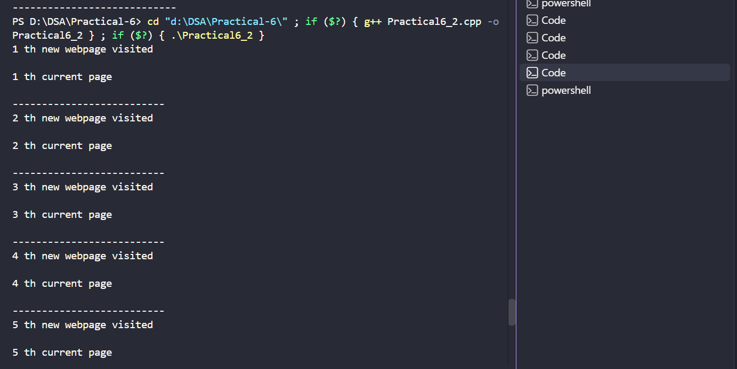

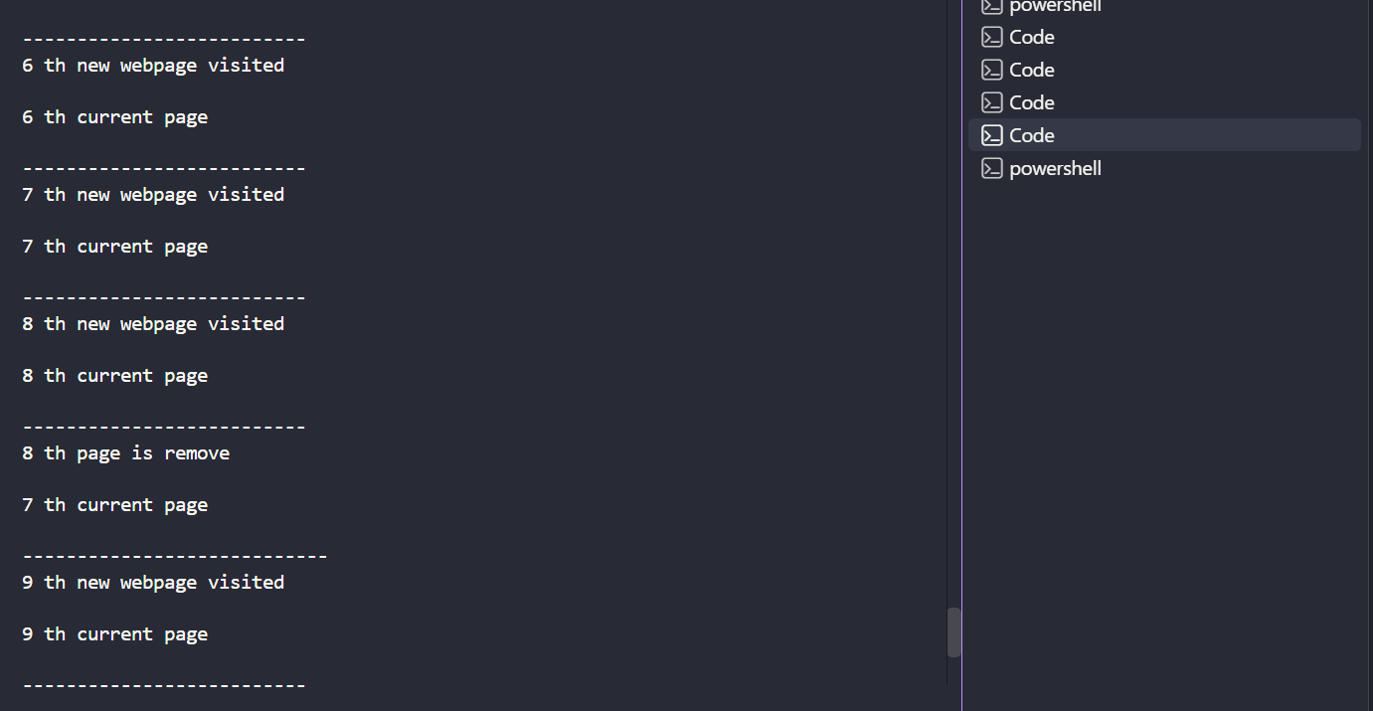

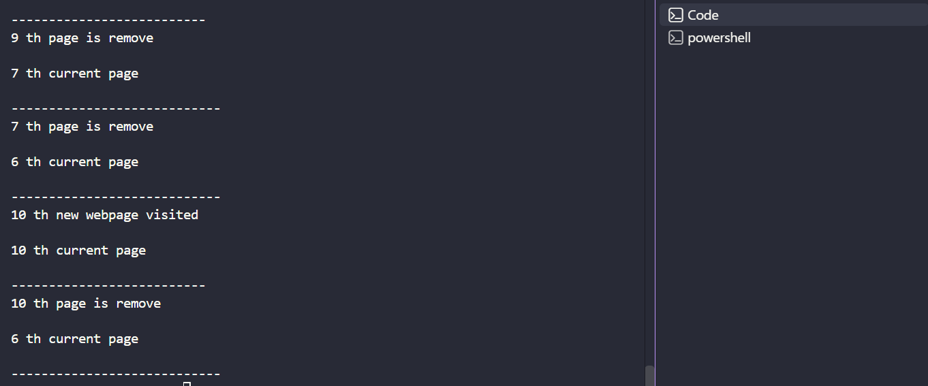

Problem 6.3:
operator precedence determines the order in which operators are placed into the output. Without tracing any expression, explain what would go wrong in your output if your solution treated all operators as having equal precedence.

Code:

https://github.com/RudraKapuriya/DSA-Practical/blob/main/Practical-6/Practical6_3.cpp

Output:
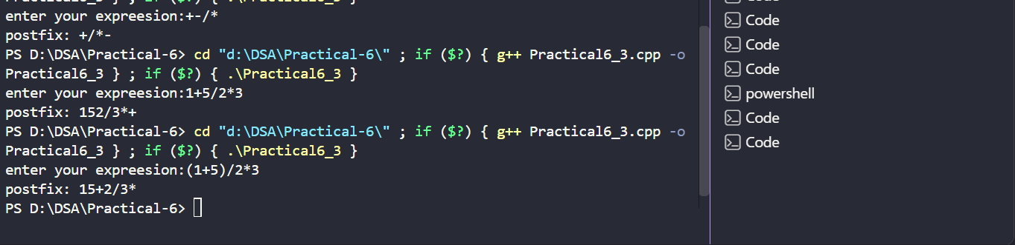

Problem Faced:
Converting the expression into postfix.

